**Ex.No. : 06 Date:17.02.2025**

**RegisterNo.:221701004 Name:Adhithya A**

SDCard

# Aim

Implement an application to write the name and CGPA to SD card in text file format.

## Procedure:

**Step1:**File->NewProject

ProvidetheapplicationnameandClick“Next”

**Step2:**Selectthetargetandroiddevices

SelecttheminimumSDKtoruntheapplication.Click“Next”.

**Step3:**Choosetheactivityfortheapplication(Bydefaultchoose“BlankActivity).

Click “Next”.

**Step4:**Enteractivitynameandclick&quot;Finish&quot;.

**Step5:**Edittheprogram.

**Step 6:** Runtheapplication,2-waystorunthe application.

1. Runningthroughemulator
2. Runningthroughmobiledevice

**DepartmentofComputerScienceandDesign**| **RajalakshmiEngineeringCollege**

.

1

## AndroidManifest.xml

<manifest xmlns:android="<http://schemas.android.com/apk/res/android>"package="com.example.ex6">

<!--Permissionsforaccessingexternalstorage-->

<uses-permissionandroid:name="android.permission.WRITE_EXTERNAL_STORAGE"

/>

<uses-permissionandroid:name="android.permission.READ_EXTERNAL_STORAGE"/>

<applicationandroid:allowBackup="true" android:icon="@mipmap/ic_launcher"android:label="SD Card File Writer"android:theme="@style/Theme.Ex6">

<!--MainActivity-->

<activity android:name=".MainActivity" android:exported="true">

<intent-filter>

<actionandroid:name="android.intent.action.MAIN"/>

<categoryandroid:name="android.intent.category.LAUNCHER"/>

</intent-filter>

</activity>

</application>

</manifest>

## Activity_main.xml

<?xmlversion="1.0"encoding="utf-8"?>

<RelativeLayout xmlns:android=["http://sche](http://sche/) mas.android.com/apk/res/a ndroid"

android:layout_width="match_parent"

2

**DepartmentofComputerScienceandDesign**| **RajalakshmiEngineeringCollege**

.

android:layout_height="match_parent">

<!--EditTextforentering Name -->

<EditText android:id="@+id/etName"

android:layout_width="match_parent"

android:layout_height="wrap_content"

android:hint="Enter Name"

android:layout_marginTop

="50dp"

android:layout_alignParent Top="true"

android:padding="16dp"/>

<!--EditTextforentering Marks -->

<EditText

android:id="@+id/etMarks"

android:layout_width="match_parent"

**DepartmentofComputerScienceandDesign**| **RajalakshmiEngineeringCollege**

.

3

android:layout_height="wrap_content"

android:hint="Enter Marks"

android:inputType="numbe r"

android:layout_below="@id

/etName"

android:layout_marginTop

="20dp"

android:padding="16dp"/>

<!-- Button to trigger the save action -->

<Button

android:id="@+id/btnSaveD ata"

android:layout_width="wra p_content"

android:layout_height="wrap_content"

android:text="Save Data"

android:layout_below="@id

4

**DepartmentofComputerScienceandDesign**| **RajalakshmiEngineeringCollege**

.

/etMarks"

android:layout_centerHoriz ontal="true"

android:layout_marginTop

="20dp"/>

</RelativeLayout>

## MainActivity.kt

packagecom.example.ex6

import android.Manifest import android.content.pm.PackageManager

import android.os.Build import android.os.Bundle import android.widget.EditText import android.widget.Toast import androidx.appcompat.app.AppCompatActivity

import androidx.core.app.ActivityCompat

import androidx.core.content.ContextCompat

importjava.io.File

**DepartmentofComputerScienceandDesign**| **RajalakshmiEngineeringCollege**

.

5

import java.io.FileOutputStream importjava.io.IOException

class MainActivity : AppCompatActivity() {

private val REQUEST_CODE_STORA GE_PERMISSION = 1

privatelateinitvar etName: EditText

privatelateinitvar etMarks: EditText

override fun onCreate(savedInstanceSta te: Bundle?) {

super.onCreate(savedInstanceState)

setContentView(R.layout.*a ctivity_main*)

// Initialize the EditText fields

etName = findViewById(R.id.*etName*)

etMarks = findViewById(R.id.*etMarks*

)

6

**DepartmentofComputerScienceandDesign**| **RajalakshmiEngineeringCollege**

.

// Check for permissions before allowing the user to save data

if (Build.VERSION.*SDK_IN T* >= Build.VERSION_CODES.

*M*){

if (ContextCompat.checkSelf Permission(

this, Manifest.permission.*WRIT E_EXTERNAL_STORAGE*

)!=

PackageManager.*PERMIS SION_GRANTED*

){

ActivityCompat.requestPer missions(

this,

*arrayOf*(Manifest.permissi on.*WRITE_EXTERNAL_S TORAGE*),

REQUEST_CODE_STORA GE_PERMISSION

)

}else{

//Permissionis

**DepartmentofComputerScienceandDesign**| **RajalakshmiEngineeringCollege**

.

7

already granted, proceed to save data

setupSaveButton()

}

}else{

// If on older versions of Android, permission is automatically granted

setupSaveButton()

}

}

// Handle permission result

override fun onRequestPermissionsResu lt(

requestCode:Int, permissions:

Array<String>,

grantResults: IntArray

){

super.onRequestPermissionsResult(requestCode, permissions,grantResults)

if (requestCode == REQUEST_CODE_STORAGE_PERMISSION) {

if

8

**DepartmentofComputerScienceandDesign**| **RajalakshmiEngineeringCollege**

.

(grantResults.*isNotEmpty*() && grantResults[0] == PackageManager.*PERMIS SION_GRANTED*) {

// Permission granted, set up the savebutton

setupSaveButton()

}else{

Toast.makeText(this, "Permission Denied", Toast.*LENGTH_SHORT*).s

how()

}

}

}

//Setupbuttonclickto save data to SD card

private fun setupSaveButton() {

val btnSaveData = findViewById<android.widget.Button>(R.id.*btnSaveD ata*)

btnSaveData.setOnClickLi stener **{**

val name = etName.*text*.toString()

valmarks=

**DepartmentofComputerScienceandDesign**| **RajalakshmiEngineeringCollege**

.

9

etMarks.*text*.toString()

if (name.*isNotEmpty*() && marks.*isNotEmpty*()) {

// Convert marks to an integer

valmarksInt= marks.*toInt*()

//Writethedata

tothefile

writeToFile(name, marksInt)

}else{

Toast.makeText(this, "Please enter both name and marks", Toast.*LENGTH_SHORT*).s

how()

}

**}**

}

// Functiontowrite the name and marks to a text file

private fun writeToFile(name: String, marks: Int) {

try{

10 **DepartmentofComputerScienceandDesign**| **RajalakshmiEngineeringCollege**

.

// Get the file path val file =

File(getExternalFilesDir(n ull), "student_marks.txt")

// Open file output stream in append mode

val fos = FileOutputStream(file, true)

//Preparecontentto be written to the file

val content = "Name:$name,Marks:

$marks\n"

fos.write(content.*toByteArr ay*())

fos.close()

Toast.makeText(this, "Data saved to SD card", Toast.*LENGTH_SHORT*).s

how()

} catch (e: IOException){

e.printStackTrace()

Toast.makeText(this, "Failed to write to file", Toast.*LENGTH_SHORT*).s

**DepartmentofComputerScienceandDesign**| **RajalakshmiEngineeringCollege**

.

1

how()

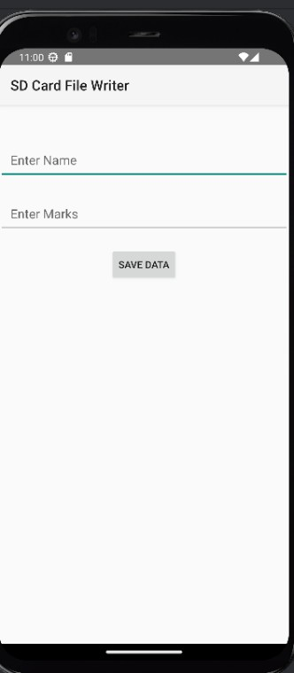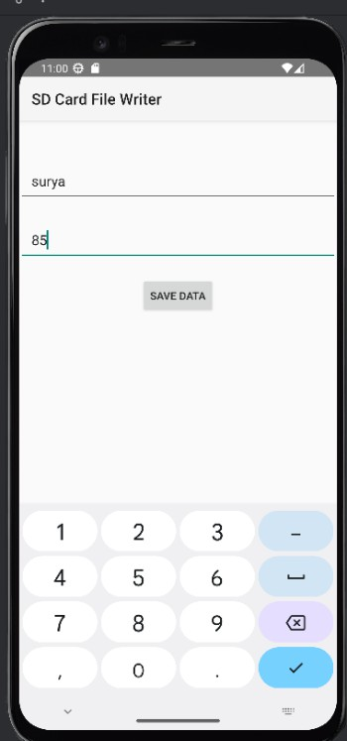

}

}

}

***Output:***

# Result:

TheApplicationwasdevelopedusingKotlininAndroidStudio.

12 **DepartmentofComputerScienceandDesign**| **RajalakshmiEngineeringCollege**

.